**Static Determinancy and Indeterminancy**

* Yes, **structural indeterminacy** generally means that a structure is **statically redundant**, meaning it has **more supports or internal forces than necessary** to maintain equilibrium.

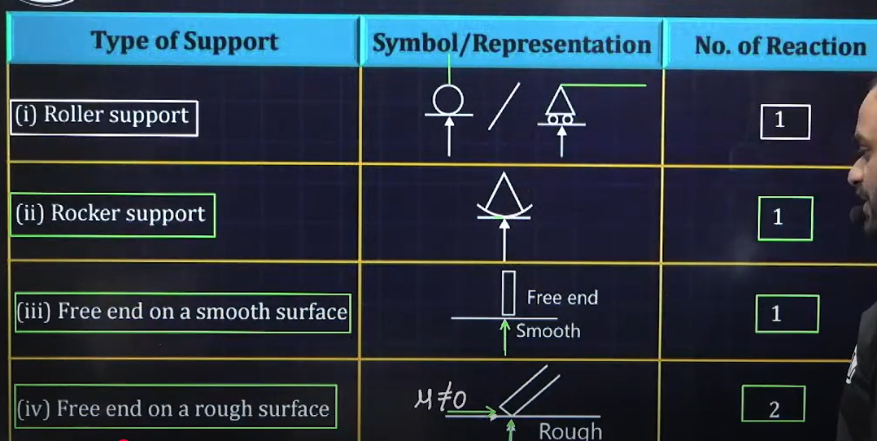

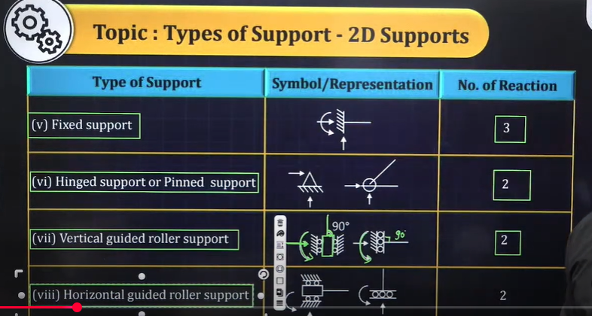

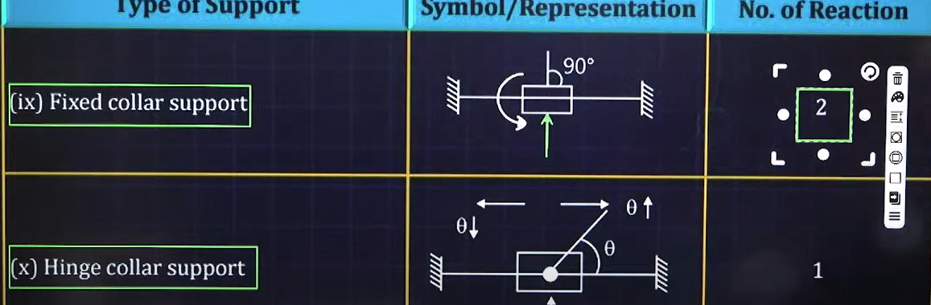

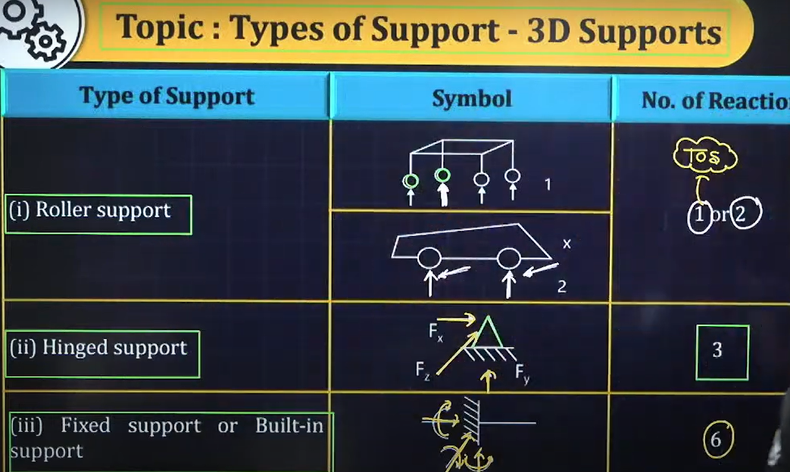

Dse=0 means externally determinate structure

Dse>0 means externally indeterminate structure(redundant structure)

Dse<0 means externally determinate structure but unstable structure

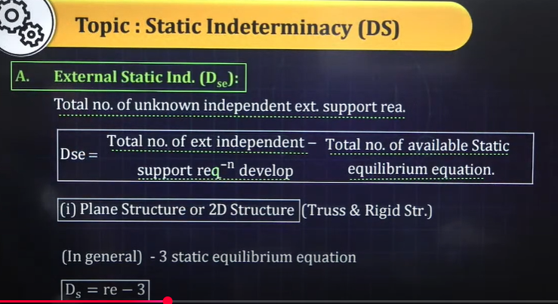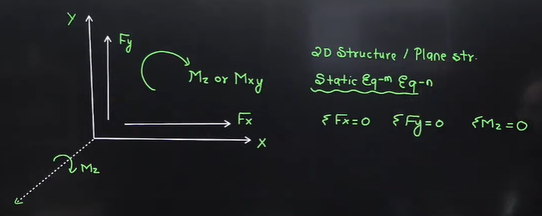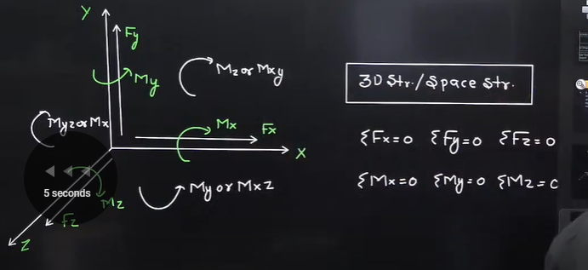

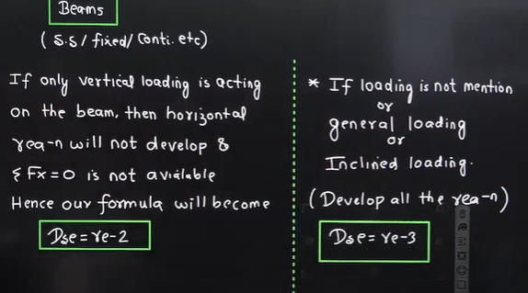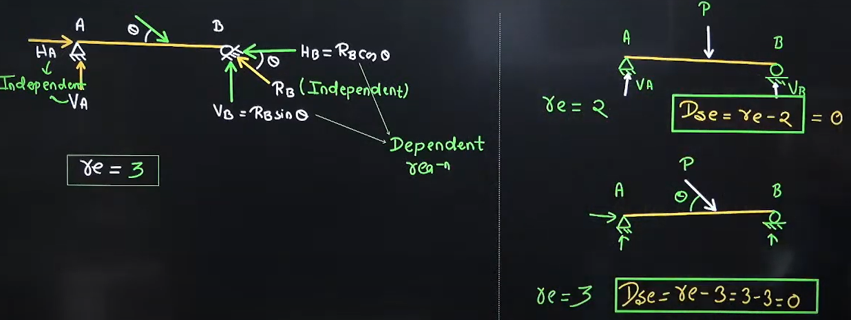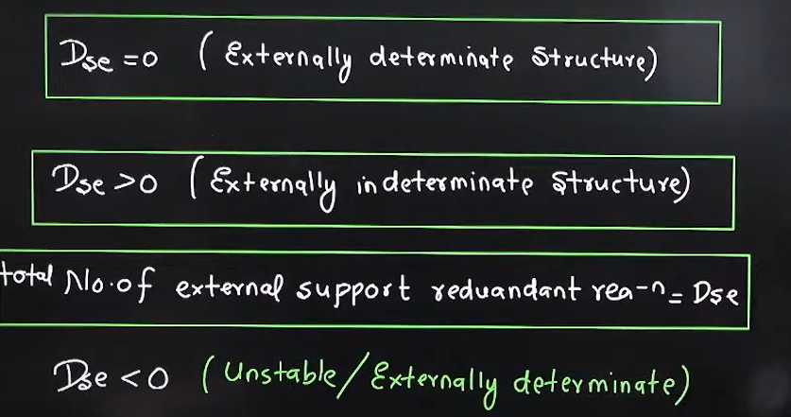

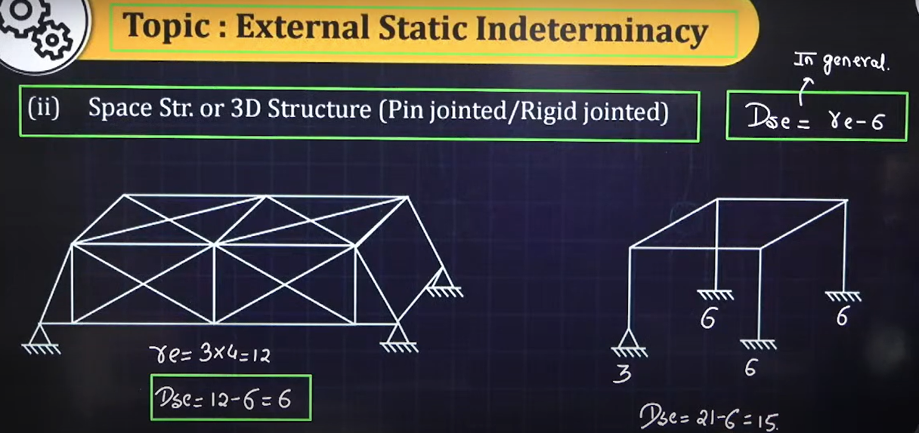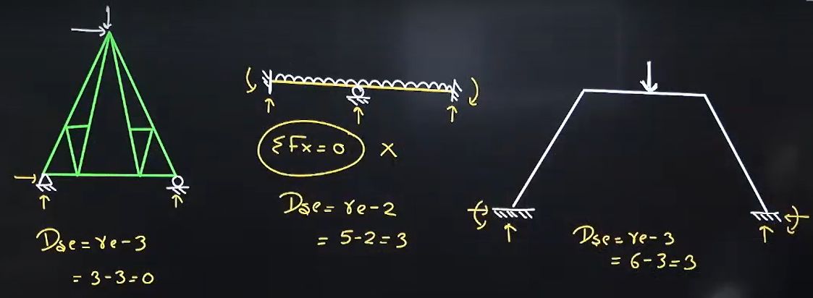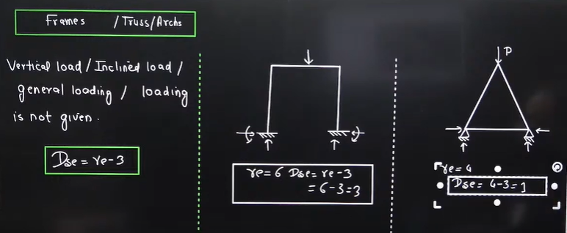// Frame/ truss /Arch k case me vertical loading v diya ho to v horiozontal reactions develop karwana hai.

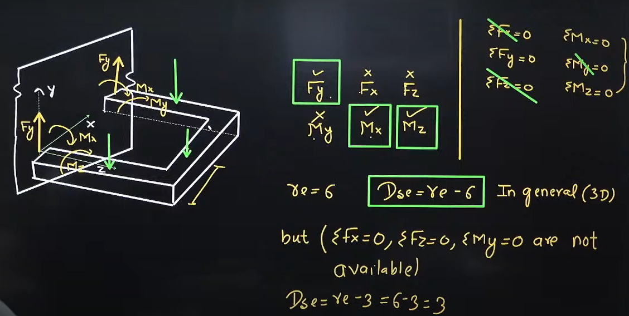

*********** Internal static indeterminancy **********

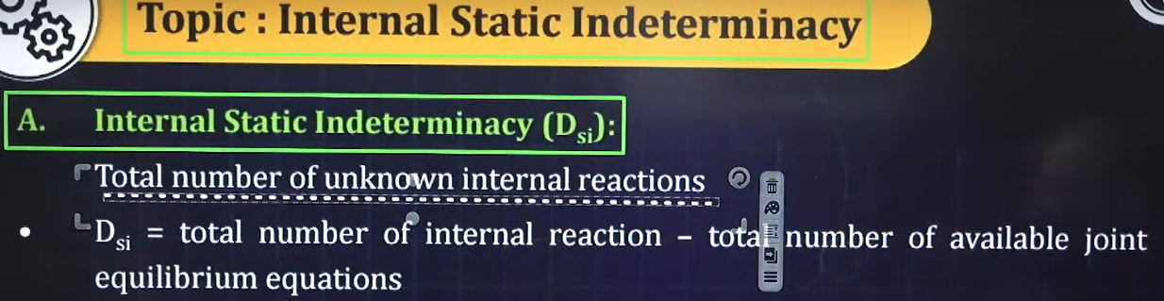

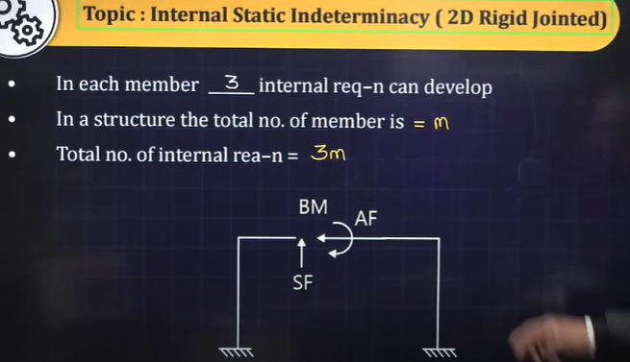

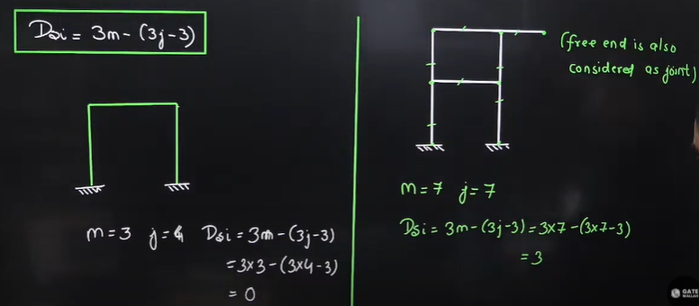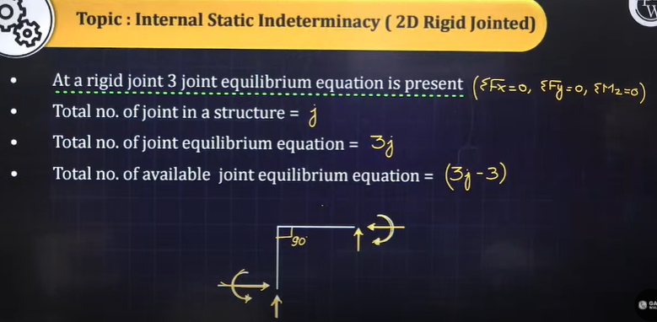

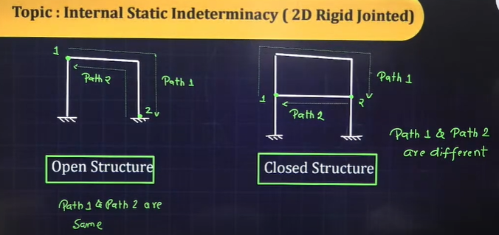

* Open structures are generally internally determinate structures (Dse=0)
* Closed structures are generally internally indeterminate structures (Dse>0)

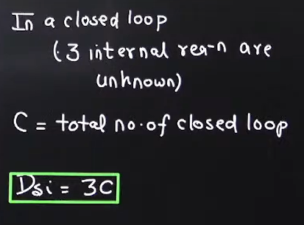2nd formula to find internal static indeterminacy.

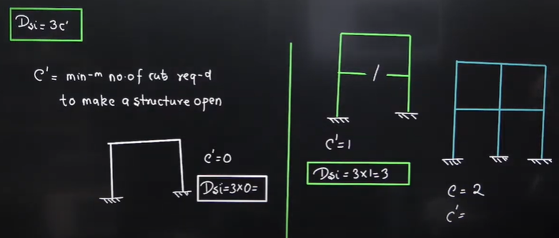3rd formula to find internal static indeterminacy.

* Internal hinge makes Bending moment 0.

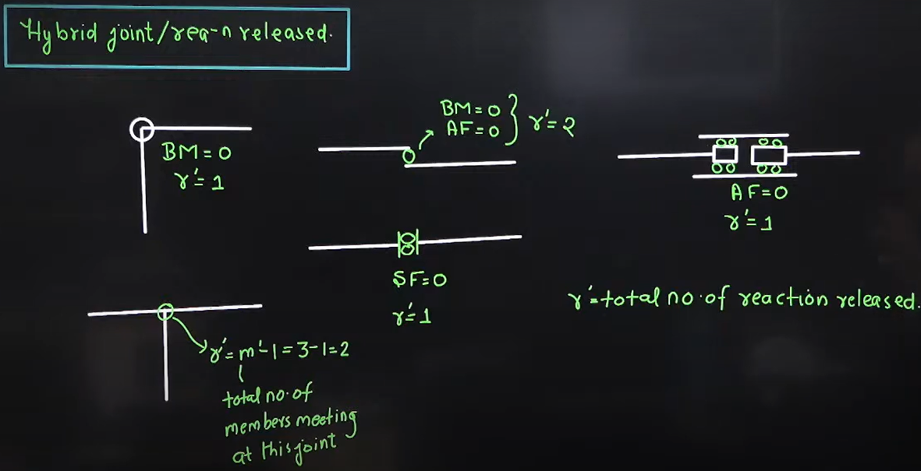

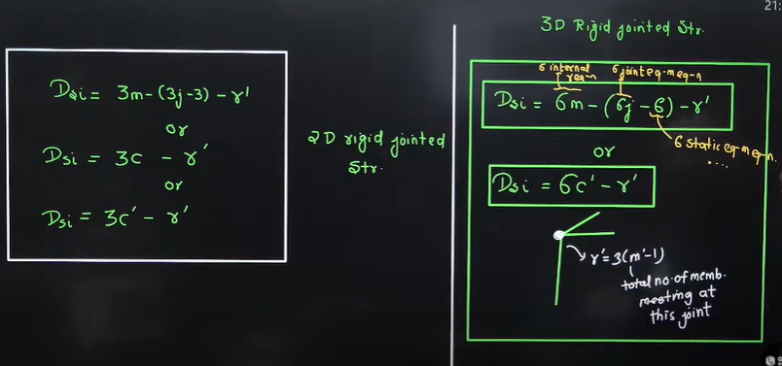

* Only for 2 D rigid jointed

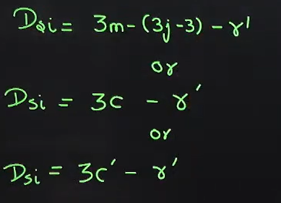

* 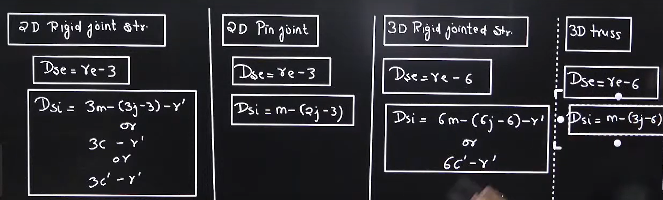Very Important formula

# Examples

1. 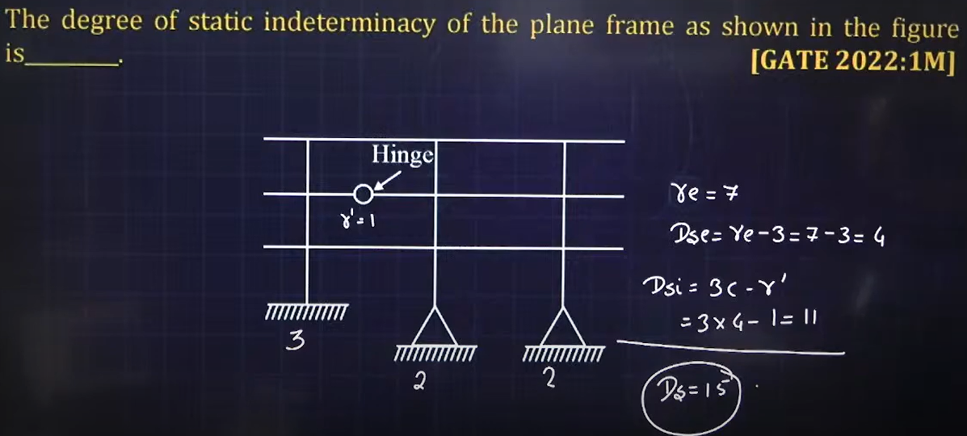

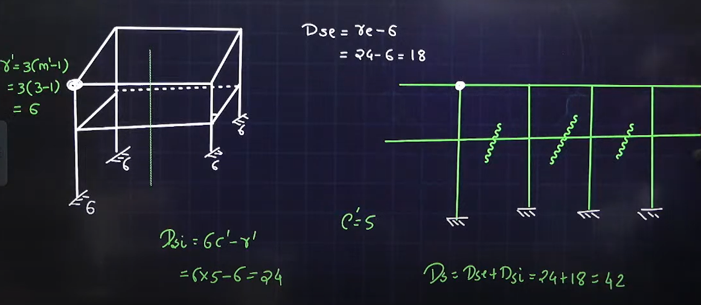

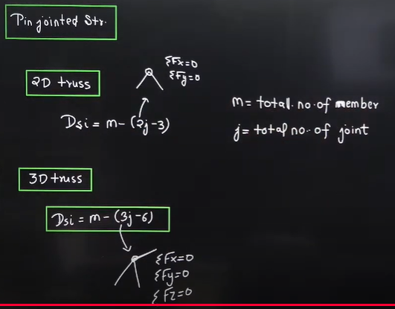

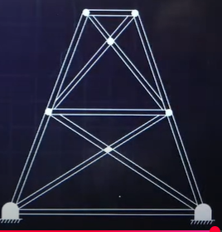Find its Dse and Dsi.

Dse= re-3= 4-3=1

Dsi= m-(2j-3) = 15-(16-3)=2

m= 15 , j= 8

Ds= Dse+Dsi= 1+2=3

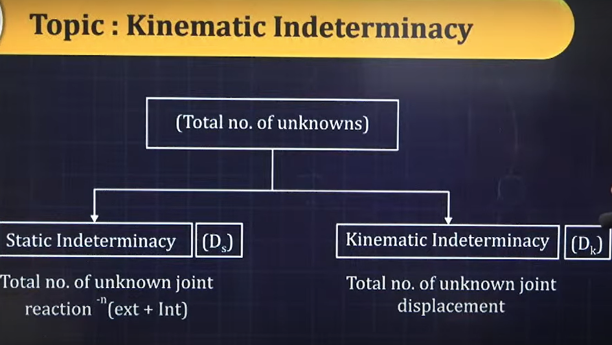

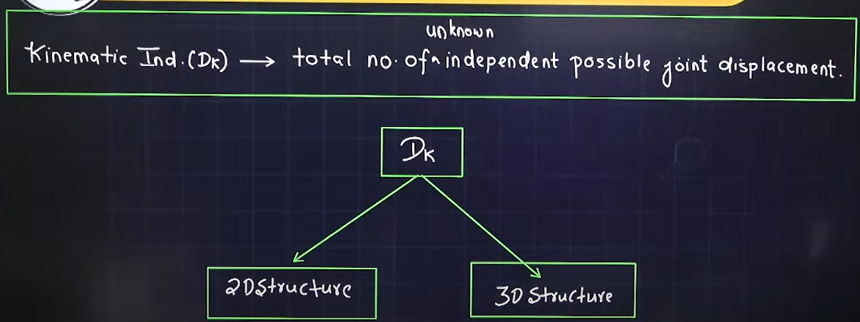

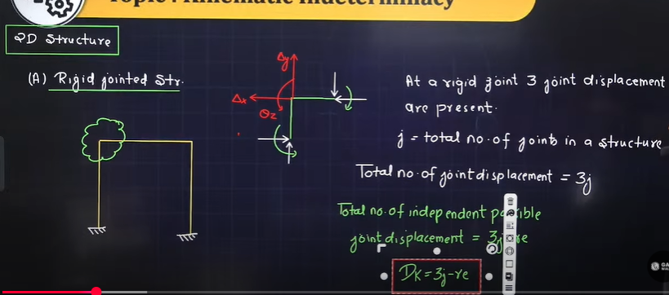

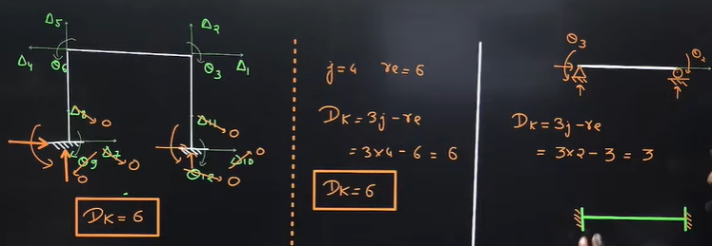

* Sway in the case of extensible member structures are dependent hence not counted.

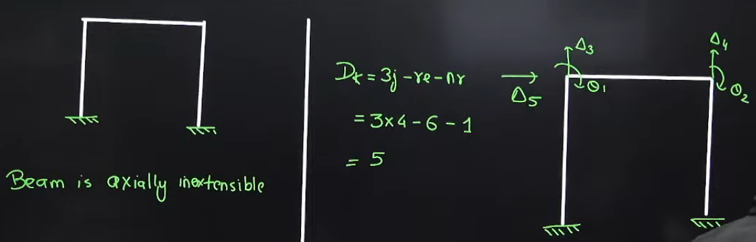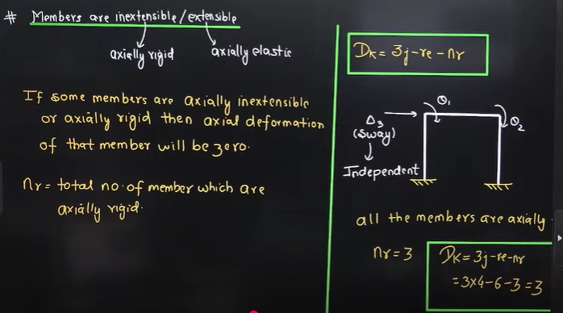

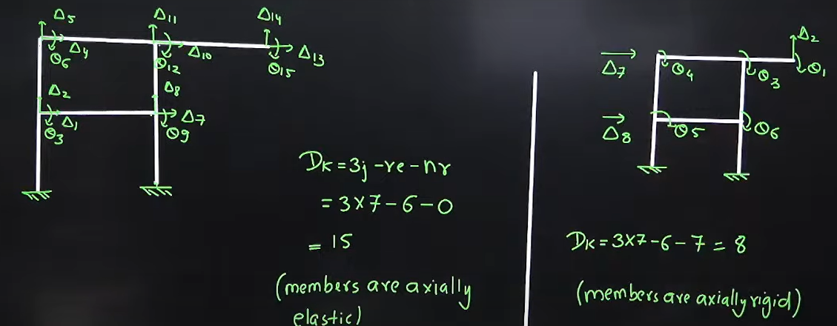

An **Influence Line Diagram (ILD)** in civil engineering is a graphical representation that shows how a moving load affects a specific response (such as shear force, bending moment, or reaction) at a particular point in a structure. It helps engineers analyze the effect of loads moving across a beam, truss, or bridge.

* Concept of ILD for calculating shear force and bending moment is applicable to both statically determinate and indeterminate structures.

